(Approx. 924 words)

Music Tagging with ID3
by Mike Moore, Editor, Bowling Green Computer Users Group, KY
www.bgamug.org
ml.moore (at) insightbb.com

This article has been obtained from APCUG with the author’s permission for publication by APCUG member groups; all other uses require the permission of the author (see e-mail address above).
MP3 is a compressed music format that can be used to fit a track of music that would normally occupy hundreds of megabytes on a Compact Disc into four or five megabytes. While some of the data is lost in this compression, it is data that cannot normally be heard in the rendering of the music file. In compressing music files this way, we can fit more music onto our music appliances, such as iPods and other MP3 players.
While the process of compressing music files is interesting for techies, it is not something we normally have to concern ourselves with, because often the music files are already in MP3 format when we acquire them. Double-click on the MP3 file and PRESTO, the song plays.
What is interesting and really required of digital music collectors is that we must keep our music organized. Since there are obviously many ways in which one can name a file of music, this is really not a very good way to keep a library organized, unless you have complete control over how a song is named.
Think of a given song. There are some obvious metrics on which the song could be organized. For starters, we have the name of the piece, the recording artist and label, the name of the band or orchestra, the genre of music, and so forth. There are dozens of less obvious metrics, such as the length of the song, when it was recorded – even who borrowed it from you and when!
These little pieces of information about a given track are known as “meta-data” or “meta-information.” This set of information is literally, data about data, because the music file itself is a kind of digital data.
The music industry has adopted a standard, known as ID3 that provides for meta-information to be included with an MP3 file. You might think of ID3 as the wrapper that an MP3 file comes surrounded in.
To view and edit this information, Windows supports ID3 by allowing you to right-click on an MP3 file and see & change all of the metainformation. You can also see a limited set of the metadata about a song by simply hovering your mouse over a music file. Here I have right-clicked on a piano piece called Impromptu in B Flat, written by Franz Schubert. Remember when you right-click to get a context menu, it’s a single right-click, not a double click.
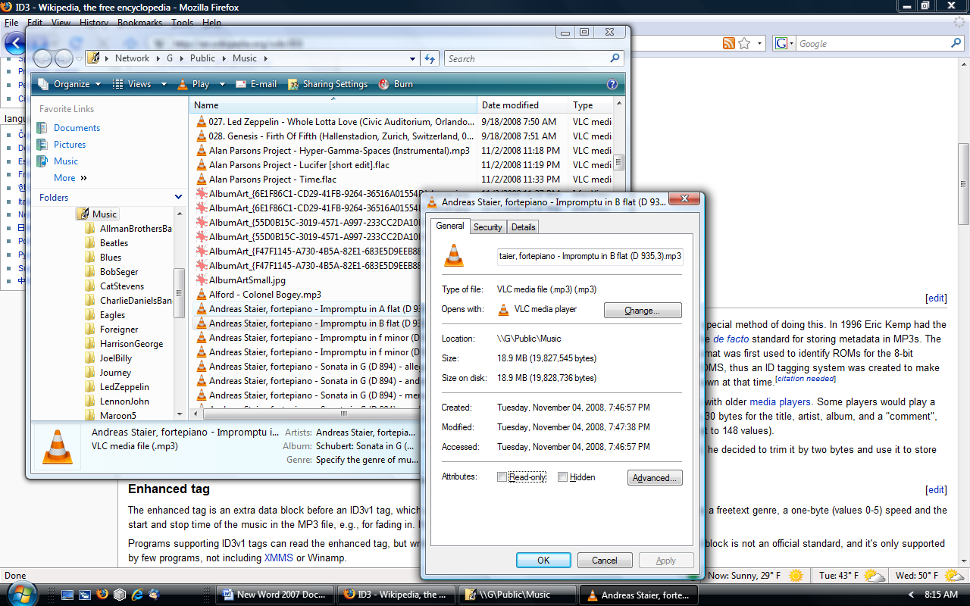
That gives me the size in Megabytes of the file, its name and where and when it was stored. If I click on the Details tab, I get all of the rest of the meta-data, including the artist and composer:
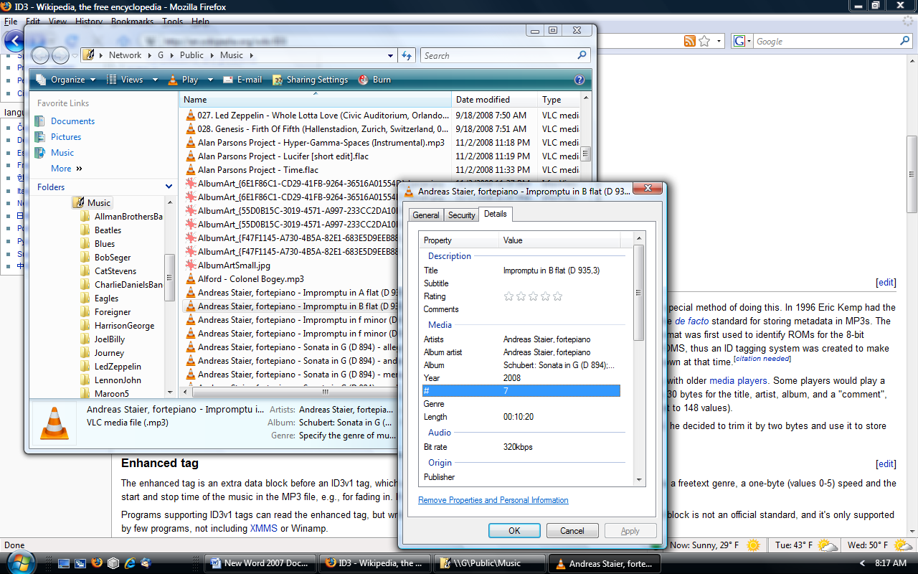
There are various versions of ID3 that have little relationship to each other. For more detailed information about ID3, read this article in Wikipedia: http://en.wikipedia.org/wiki/ID3.
The good news is that most modern MP3 players, when encountering ID3, simply ignore it when playing back the music. So we have music data inside of an MP3 file that we hear, and ID3 data that we can see when we right-click on the file.
So, here we have a way in which you can see the meta-data about one particular song. But suppose I wanted to organize and manipulate a large number of songs – even to the extent of pulling this information out of the meta-data fields that we see and using it to construct a meaningful file name? After all, file names are the basis for how Windows stores files, so it would make sense that we might want our music files named in a very particular way. One of the standards I use is to organize music in folders that are named corresponding to the artist that recorded the song.
It turns out that there are many ID3 capturing and editing utility programs out on the internet (many of which actually cost money), and I’m going to mention just one of them: TagScanner.
In tech circles, the ID3 meta-data information that is imbedded at the end of a music file is known commonly as a “tag.”
Who would enjoy sitting at their computer typing in album and artist information for each track? With the free TagScanner, you don't have to. This efficient and powerful tag editor lets you edit and collect meta-data automatically as well as by hand, both for individual files and file batches.
The automatic tagging feature is most impressive. Although it can hook up to online databases such as FreeDB, Gracenote, and Amazon like many other auto-tagging applications, it can also generate tags from file and folder names--something many others can't. It works in the opposite direction, too, generating filenames from tags. This is very important, because many files come to us virtually unusable from a sorting point of view, because their file names begin with, say, a catalog number that means nothing to our sorting scheme.
TagScanner has an elegant and orderly interface, and lets you preview filenames before applying changes. The only catch is that you'll need to spend some time learning the program's file- and tag-naming language. However, if you have thousands of music tracks crying out for organization, that's a small price to pay.
Get TagScanner (free) at: http://www.xdlab.ru/en/
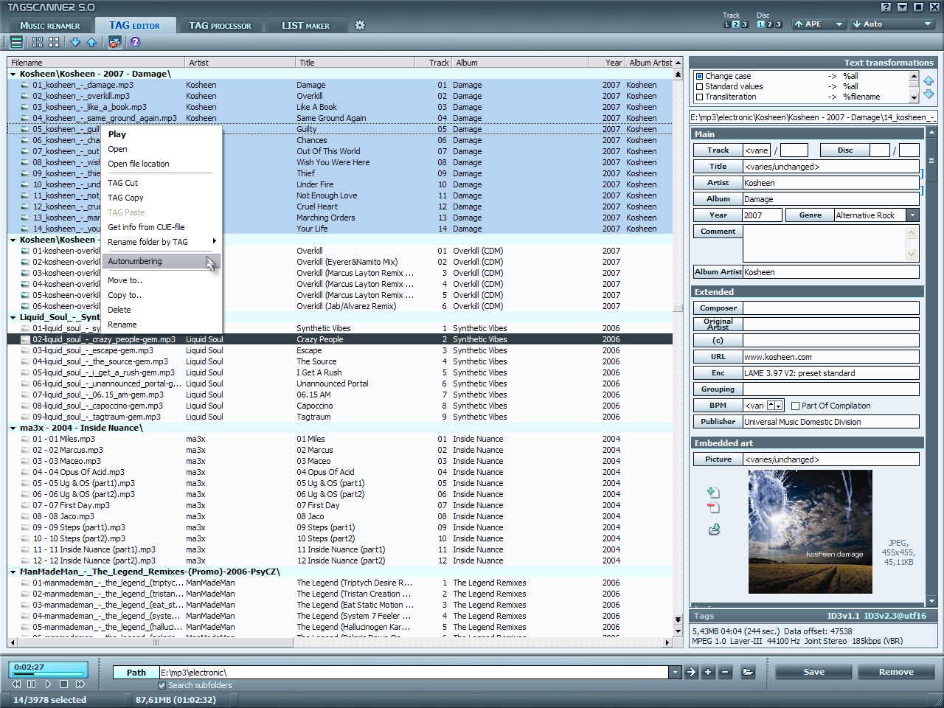
The main TagScanner window:

